**INTRODUCTION TO PROJECT**

The project entitled “**Ambiance- Mood Based Music Web Application**”, allows the user to play music according to his mood, through a list of moods provided. Music is a vital mood controller and helps in improving the mood and state of the person which in turn will act as a catalyst to increase productivity. Continuous music play requires creating and managing personalized song playlist which is a time consuming task. It would be very helpful if the music player itself selects a song according to the current mood of the user. The application provides a list of moods through which a user can select his/her mood from the given tiles, or through the dropdown menu provided. On clicking upon a particular mood, a new webpage is opened with the suggested songs.

The music player opened with a list of songs, is a standard music player with following controls-

1. Play on click of play icon
2. Pause on click of pause icon
3. Play/Pause on key press (Spacebar)
4. Mute
5. Volume Increase
6. Volume Decrease
7. Shuffle
8. Loop
9. Search
10. Sort

The application is made by using many modules and frameworks. Some of them are listed below-

1. HTML-5
2. CSS-3
3. BOOTSTRAP
4. JAVASCRIPT
5. JQUERY

The web application uses many plug-ins and CDN links apart from the ones listed above. CDN (Content Delivery Network) that deliver pages and other Web content to a user, based on the geographic locations of the user, the origin of the webpage and the content delivery server.

This service is effective in speeding the delivery of content of websites with high traffic and websites that have global reach. The closer the CDN server is to the user geographically, the faster the content will be delivered to the user. CDNs also provide protection from large surges in traffic. Servers nearest to the website visitor respond to the request made by user. The content delivery network copies the pages of a website to a network of servers that are dispersed at geographically different locations, caching the contents of the page. When a user requests a webpage that is part of a content delivery network, the CDN will redirect the request from the originating site's server to a server in the CDN that is closest to the user and deliver the cached content. CDNs will also communicate with the originating server to deliver any content that has not been previously cached.

The process of bouncing through CDNs is nearly transparent to the user. The only way a user would know if a CDN has been accessed is if the delivered URL is different than the URL that has been requested.

**DataTables** is a plug-in for the jQuery JavaScript library. It is a highly flexible tool, based upon the foundations of progressive enhancement, and will add advanced interaction controls to any HTML table.

Some features of datatables are-

1. Pagination, instant search and multi-column ordering
2. Supports almost any data source:

DOM, JavaScript, Ajax and server-side processing

1. Easily theme-able: DataTables, jQuery UI, Bootstrap, Foundation
2. Wide variety of extensions inc. Editor, Buttons, Fixed Columns
3. Extensive options and a beautiful, expressive API
4. Fully internationalisable.
5. Professional quality: backed by a suite of 2900+ unit tests.

The entire project is uploaded to github. GitHub is a web-based Git or version control repository and Internet hosting service. It is mostly used for code. It offers all of the distributed version control and source code management (SCM) functionality of Git as well as adding its own features. It provides access control and several collaboration features such as bug tracking, feature requests, task management, and wikis for every project.

GitHub offers both plans for private and free repositories on the same account which are commonly used to host open-source software projects. As of April 2017, GitHub reports having almost 20 million users and 57 million repositories, making it the largest host of source code in the world.

Projects on GitHub can be accessed and manipulated using the standard Git command-line interface and all of the standard Git commands work with it. GitHub also allows registered and non-registered users to browse public repositories on the site. Multiple desktop clients and Git plugins have also been created by GitHub and other third parties that integrate with the platform.

The site provides social networking-like functions such as feeds, followers, wikis (using wiki software called Gollum) and a social network graph to display how developers work on their versions ("forks") of a repository and what fork (and branch within that fork) is newest.

A user must create an account in order to contribute content to the site, but public repositories can be browsed and downloaded by anyone. With a registered user account, users are able to discuss, manage, create repositories, submit contributions to others' repositories, and review changes to code.

**LIVE LINK: -** https://jiteshbhola.github.io/MoodBasedWebApplication/

**SOURCE CODE:** - https://github.com/jiteshbhola/MoodBasedWebApplication

**FEATURES OF PROJECT**

1. Search in every page of the app.
2. Elegant user interface
3. Compatible in all mobile phones, tablets and large screens too.
4. Categorization of songs as per their mood.
5. Volume control button in the app
6. Key press event on Spacebar
7. Shuffle button
8. Repeat button
9. Sorting in 5 different ways
10. Completely Ad-free
11. Excellent audio quality
12. Auto-playlist generation based on mood.

**PLATFORMS/TECHNOLOGIES USED**

**The technologies used in this project are as follows-**

1. HTML 5
2. CSS 3
3. Bootstrap
4. JavaScript
5. jQuery
6. GitHub
7. CDN

**HTML 5**

HTML, which stands for Hyper Text Markup Language, is the predominant markup language for web pages. It provides a means to create structured documents by denoting structural semantics for text such as headings, paragraphs, lists etc as well as for links, quotes, and other items. It allows images and objects to be embedded and can be used to create interactive forms. It is written in the form of HTML elements consisting of "tags" surrounded by angle brackets within the web page content. It can include or can load scripts in languages such as JavaScript which affect the behavior of HTML processors like Web browsers; and Cascading Style Sheets (CSS) to define the appearance and layout of text and other material. The W3C, maintainer of both HTML and CSS standards, encourages the use of CSS over explicit presentational markup. Hyper Text Markup Language (HTML) is the encoding scheme used to create and format a web documents.

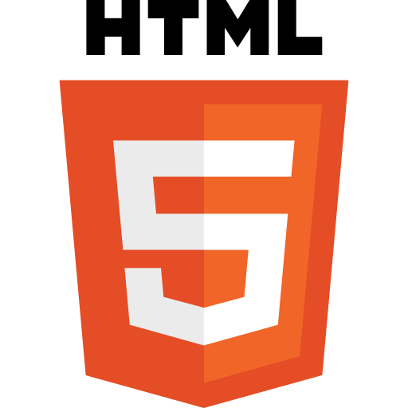

HTML5 introduces elements and attributes that reflect typical usage on modern websites. Some of them are semantic replacements for common uses of generic block (<div>) and inline (<span>) elements, for example <nav> (website navigation block), <footer> (usually referring to bottom of web page or to last lines of HTML code), or <audio> and <video> instead of <object>.Some deprecated elements from HTML 4.01 have been dropped, including purely presentational elements such as <font> and <center>, whose effects have long been superseded by the more capable Cascading Style Sheets. There is also a renewed emphasis on the importance of DOM scripting (e.g., JavaScript) in Web behavior.

* **FEAUTRES OF HTML 5 :-**

1. **Video elements:** Designers can now build web pages without having to resort to third-party proprietary plug-in software like Flash. YouTube is experimenting with using HTML 5 to display video. Built in video controls makes the feature more attractive and easy to use.
2. **Application cache:** On the lines of Outlook but minus the email client requirement, you can now store web apps much like emails locally. Google has already made use of this feature replacing its Google Gears mail client with HTML 5. Google Wave also uses HTML-5.
3. **Canvas for Images**: The canvas element that comes with HTML 5 lets you manipulate graphics and photos enabling easy rendering of images. Designers no longer need to use intermediate technologies like jQuery. This will help save development time and effort.
4. **Geolocation:** The HTML5 Geolocation feature enables location identification using various geo location technologies GPS (Global Positioning system), IP address, RFID (Radio frequency ID), Wi-Fi , Bluetooth MAC address and GSM/CDMA cell IDs. The system is bound by privacy regulations and needs to be authorized by individuals before it can be utilized.
5. **Web workers**: This feature enables a web application to execute complex tasks independently without interfering with the performance of a webpage in real-time.

**CSS 3**

Cascading Style Sheets (CSS) is a style sheet language used for describing the presentation of a document written in a markup language. Although most often used to set the visual style of web pages and user interfaces written in HTML and XHTML, the language can be applied to any XML document, including plain XML, SVG and XUL, and is applicable to rendering in speech, or on other media. Along with HTML and JavaScript, CSS is a cornerstone technology used by most websites to create visually engaging webpages, user interfaces for web applications, and user interfaces for many mobile applications.

CSS is designed primarily to enable the separation of presentation and content, including aspects such as the layout, colors, and fonts. This separation can improve content accessibility, provide more flexibility and control in the specification of presentation characteristics, enable multiple HTML pages to share formatting by specifying the relevant CSS in a separate .css file, and reduce complexity and repetition in the structural content.

Separation of formatting and content makes it possible to present the same markup page in different styles for different rendering methods, such as on-screen, in print, by voice (via speech-based browser or screen reader), and on Braille-based tactile devices. It can also display the web page differently depending on the screen size or viewing device. Readers can also specify a different style sheet, such as a CSS file stored on their own computer, to override the one the author specified.

CSS3 is the latest evolution of the Cascading Style Sheets language and aims at extending CSS 2.1. It brings a lot of long-awaited novelties, like rounded corners, shadows, gradients, transitions or animations, as well as new layouts like multi-columns, flexible box or grid layouts. Experimental parts are vendor-prefixed and should either be avoided in production environments, or used with extreme caution as both their syntax and semantics can change in the future.

Unlike CSS 2, which is a large single specification defining various features, CSS 3 is divided into several separate documents called "modules". Each module adds new capabilities or extends features defined in CSS 2, preserving backward compatibility. Work on CSS level 3 started around the time of publication of the original CSS 2 recommendation. The earliest CSS 3 drafts were published in June 1999.

Due to the modularization, different modules have different stability and statuses. As of June 2012, there are over fifty CSS modules published from the CSS Working Group.,and four of these have been published as formal recommendations:

* 2012-06-19: Media Queries
* 2011-09-29: Namespaces
* 2011-09-29: Selectors Level 3
* 2011-06-07: Color

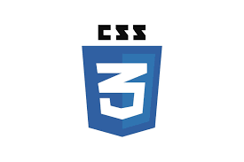

* **IMPORTANT CSS 3 MODULES-**

1. Selectors
2. Box Model
3. Backgrounds and Borders
4. Image Values and Replaced Content
5. Text Effects
6. 2D/3D Transformations
7. Animations
8. Multiple Column Layout
9. User Interface

**BOOTSTRAP**

Bootstrap is a free and open-source front-end web framework for designing websites and web applications. It contains HTML- and CSS-based design templates for typography, forms, buttons, navigation and other interface components, as well as optional JavaScript extensions. Unlike many web frameworks, it concerns itself with front-end development only. Bootstrap is the second most-starred project on GitHub, with more than 111,600 stars and 51,500 forks.

Bootstrap, originally named Twitter Blueprint, was developed by Mark Otto and Jacob Thornton at Twitter as a framework to encourage consistency across internal tools. Before Bootstrap, various libraries were used for interface development, which led to inconsistencies and a high maintenance burden. According to Twitter developer Mark Otto:

***"A super small group of developers and I got together to design and build a new internal tool and saw an opportunity to do something more. Through that process, we saw ourselves build something much more substantial than another internal tool. Months later, we ended up with an early version of Bootstrap as a way to document and share common design patterns and assets within the company."***

After a few months of development by a small group, many developers at Twitter began to contribute to the project as a part of Hack Week, a hackathon-style week for the Twitter development team. It was renamed from Twitter Blueprint to Bootstrap, and released as an open source project on August 19, 2011. It has continued to be maintained by Mark Otto, Jacob Thornton, and a small group of core developers, as well as a large community of contributors.

Bootstrap 3 supports the latest versions of the Google Chrome, Firefox, Internet Explorer, Opera, and Safari (except on Windows). It additionally supports back to IE8 and the latest Firefox Extended Support Release (ESR).

Since 2.0, Bootstrap supports responsive web design. This means the layout of web pages adjusts dynamically, taking into account the characteristics of the device used (desktop, tablet, mobile phone). Starting with version 3.0, Bootstrap adopted a mobile-first design philosophy, emphasizing responsive design by default. The version 4.0 alpha release added Sass and flexbox support.

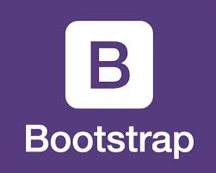

* **Features of bootstrap-**
  + 1. **Easy to Use-** It is extremely an easy and speedy procedure to begin with Bootstrap. Bootstrap is very adaptable too. You can utilize Bootstrap along with CSS, or LESS, or also with Sass [after you download the Sass version].
    2. **Responsiveness-** Every year mobile devices persist to grow hugely popular, and the requirement to have a responsive website has become compulsory and important too. As the fluid grid layout amends vigorously to the appropriate screen resolution, thus crafting a mobile-ready site is a smooth and easy task along with Bootstrap. With the use of ready-made classes of Bootstrap, you can recognize the number of spots in the grid system that you would like each column to engage in. Then only you can identify at whichever point you would like your columns to load in horizontal position, instead of vertically to exhibit accurately on mobile appliances.
    3. **The Speed of the Development-** One of the main benefits of utilizing Bootstrap happens to be the speed of the development. While driving out a new, fresh website or application swiftly, you should certainly reflect upon utilizing Bootstrap. Instead of coding from scrape, Bootstrap lets you to use ready-made coding blocks in order to assist you in setting up. You can blend that along with CSS-Less functionality and cross-browser compatibility that can give way to saving of ample hours of coding. You can even buy ready-made Bootstrap themes and alter them to fit your requirements, for gaining the quickest potential route.
    4. **Customizable Bootstrap-** The Bootstrap can be customized as per the designs of your project. The web developers can make a choice to select the aspects which are required which can be simply complete by utilizing Bootstrap customize page. You just have to tick off all the aspects that you do not require, such as- Common CSS: typography, code, grid system, tables, buttons, forms, print media styles; Components: input groups, button groups, pager, labels, navs, navbar, badges, pagination; JavaScript components: dropdowns, popovers, modals, tooltips, carousels; Utilities: Responsive utilities, basic utilities. Thus your custom version of Bootstrap is all set for download process.
    5. **Consistency-** Few Twitter employees firstly expanded Bootstrap as a framework for boosting the consistency across interior tools. But later the Co-founder Mark Otto after understanding the actual potential released in August 2011 the first open-source version of Bootstrap. He even portrayed how the Bootstrap was enlarged with the use of one core concept- pairing of designers along with developers. Thus Bootstrap became popular on Twitter.
    6. **Support-** As Bootstrap holds a big support community, you can be provided with help whenever there comes any problem. The creators always keep the Bootstrap updated. Presently Bootstrap is hosted, expanded, and preserved on the GitHub along with more than 9,000 commits, as well as more than 500 contributors.
    7. **Packaged JavaScript Components-** Bootstrap approaches with a pack of JavaScript components for including the functionality that crafts it in simple way for operating things, such as tooltips, modal windows, alerts, etc. You can even leave out the writing scripts completely.
    8. **Simple Integration-** Bootstrap can be simply integrated along with distinct other platforms and frameworks, on existing sites and new ones too. You can also utilize particular elements of Bootstrap along with your current CSS.
    9. **Grid-** Bootstrap has the capability to utilize a 12-column grid that is responsive. It also upholds offset and nested elements. The grid can be maintained in a responsive mode, or you can simply modify it to a secured layout.
    10. **Pre-styled Components-** Bootstrap approaches with pre-styled components for alerts, dropdowns, nav bars, etc. Hence, being a feature-rich, Bootstrap provides numerous advantages of using it. Hope you would have understood the above reasons so that you can easily use Bootstrap for making superb web designs for your sites!

**JAVASCRIPT**

JavaScript, often abbreviated as JS, is a high-level, dynamic, weakly typed, object-based, multi-paradigm, and interpreted programming language. Alongside HTML and CSS, As a multi-paradigm language, JavaScript supports event-driven, functional, and imperative (including object-oriented and prototype-based) programming styles. It has an API for working with text, arrays, dates, regular expressions, and basic manipulation of the DOM, but does not include any I/O, such as networking, storage, or graphics facilities, relying for these upon the host environment in which it is embedded.

Initially only implemented client-side in web browsers, JavaScript engines are now embedded in many other types of host software, including server-side in web servers and databases, and in non-web programs such as word processors and PDF software, and in runtime environments that make JavaScript available for writing mobile and desktop applications, including desktop widgets.

Although there are strong outward similarities between JavaScript and Java, including language name, syntax, and respective standard libraries, the two languages are distinct and differ greatly in design; JavaScript was influenced by programming languages such as Self and Scheme.

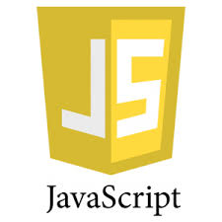

* **Features of JS –**

1. JavaScript is a object-based scripting language.
2. Giving the user more control over the browser.
3. It Handling dates and time.
4. It Detecting the user's browser and OS,
5. It is light weighted.
6. JavaScript is a scripting language and it is not java.
7. JavaScript is interpreter based scripting language.
8. JavaScript is case sensitive.
9. JavaScript is object based language as it provides predefined objects.
10. Every statement in JavaScript must be terminated with semicolon (;).
11. Most of the JavaScript control statements syntax is same as syntax of control statements in C language
12. An important part of JavaScript is the ability to create new functions within scripts. Declare a function in JavaScript using **function** keyword.

.

**JQUERY**

jQuery is a fast, small, and feature-rich JavaScript library. It makes things like HTML document traversal and manipulation, event handling, animation, and Ajax much simpler with an easy-to-use API that works across a multitude of browsers. With a combination of versatility and extensibility, jQuery has changed the way that millions of people write JavaScript. jQuery's syntax is designed to make it easier to navigate a document, select DOM elements, create animations, handle events, and develop Ajax applications. jQuery also provides capabilities for developers to create plug-ins on top of the JavaScript library. This enables developers to create abstractions for low-level interaction and animation, advanced effects and high-level, themeable widgets. The modular approach to the jQuery library allows the creation of powerful dynamic web pages and Web applications.

The set of jQuery core features—DOM element selections, traversal and manipulation—enabled by its selector engine (named "Sizzle" from v1.3), created a new "programming style", fusing algorithms and DOM data structures. This style influenced the architecture of other JavaScript frameworks like YUI v3 and Dojo, later stimulating the creation of the standard Selectors API.

Microsoft and Nokia bundle jQuery on their platforms. Microsoft includes it with Visual Studio for use within Microsoft's ASP.NET AJAX and ASP.NET MVC frameworks while Nokia has integrated it into the Web Run-Time widget development platform.



* **Features of jQuery-**

1. DOM element selections using the multi-browser open source selector engine *Sizzle*, a spin-off of the jQuery project
2. DOM manipulation based on CSS selectors that uses elements' names and attributes, such as id and class, as criteria to select nodes in the DOM
3. Events
4. Effects and animations
5. Ajax
6. Deferred and Promise objects to control asynchronous processing
7. JSON parsing
8. Extensibility through plug-ins
9. Utilities, such as feature detection
10. Compatibility methods that are natively available in modern browsers, but need fall backs for older ones, such as inArray() and each()
11. Multi-browser (not to be confused with cross-browser) support

**AJAX**

Ajax ("asynchronous JavaScript and XML") is a set of Web development techniques using many Web technologies on the client side to create asynchronous Web applications. With Ajax, Web applications can send data to and retrieve from a server asynchronously (in the background) without interfering with the display and behaviour of the existing page. By decoupling the data interchange layer from the presentation layer, Ajax allows for Web pages, and by extension Web applications, to change content dynamically without the need to reload the entire page. In practice, modern implementations commonly substitute JSON for XML due to the advantages of being native to JavaScript.

Ajax is not a single technology, but rather a group of technologies. HTML and CSS can be used in combination to mark up and style information. The DOM is accessed with JavaScript to dynamically display – and allow the user to interact with – the information presented. JavaScript and the XML-Http-Request object provide a method for exchanging data asynchronously between browser and server to avoid full page reloads.

In a nutshell, it is the use of the XML-Http-Request object to communicate with servers. It can send and receive information in various formats, including JSON, XML, HTML, and text files. AJAX’s most appealing characteristic is its "asynchronous" nature, which means it can communicate with the server, exchange data, and update the page without having to refresh the page. The two major features of AJAX allow you to do the following:

* Make requests to the server without reloading the page
* Receive and work with data from the server

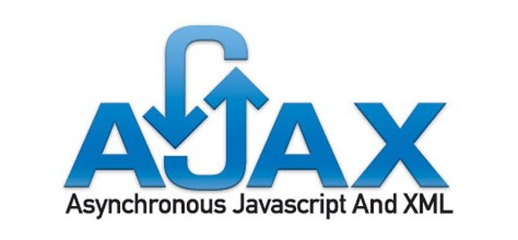

**JSON**

JSON is a local standard for exchanging data on the web. JSON support data structure like object and array. It is very easy to write and read data from JSON. The full form of JSON is JavaScript object notation. It is open standard data In-change format. It is light weight and self describe. JSON is language Independent.

**JSON Objects:-**

These hold key and value pair. Each key is represented as a string in JSON and value can be of any type. Each key and value pair is separated by comma. Key and value is separated by colon.

**JSON Array:-**

It represent ordered list of value. JSON array can store multiple values. It can store string number Boolean or JSON in array.

**Object in Array:-**

We can integrate JSON with PHP. PHP provide different kind of function to encode and decode the JSON array.

JSON encode function is used to encoding the JSON value and represent the PHP value with JSON representation format.

JSON decode function is used to decode the JSON string to PHP variable.

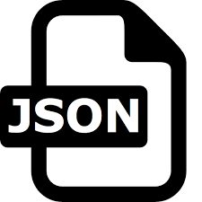.

JSON (JavaScript Object Notation) is a lightweight data-interchange format. It is easy for humans to read and write. It is easy for machines to parse and generate. It is based on a subset of the JavaScript Programming Language, Standard ECMA-262 3rd Edition - December 1999. JSON is a text format that is completely language independent but uses conventions that are familiar to programmers of the C-family of languages, including C, C++, C#, Java, JavaScript, Perl, Python, and many others. These properties make JSON an ideal data-interchange language.

JSON is built on two structures:

* A collection of name/value pairs. In various languages, this is realized as an object, record, struct, dictionary, hash table, keyed list, or associative array.
* An ordered list of values. In most languages, this is realized as an array, vector, list, or sequence.

These are universal data structures. Virtually all modern programming languages support them in one form or another. It makes sense that a data format that is interchangeable with programming languages also be based on these structures.

* **Features of JSON:-**

1. Simplicity
2. Openness
3. Self- Describing
4. Extensibility
5. Inter-Operability

**API**

In computer programming, an Application Programming Interface (API) is a set of subroutine definitions, protocols, and tools for building application software. In general terms, it is a set of clearly defined methods of communication between various software components. A good API makes it easier to develop a computer program by providing all the building blocks, which are then put together by the programmer. An API may be for a web-based system, operating system, database system, computer hardware or software library. An API specification can take many forms, but often includes specifications for routines, data structures, object classes, variables or remote calls. POSIX, Microsoft Windows API, the C++ Standard Template Library and Java APIs are examples of different forms of APIs. Documentation for the API is usually provided to facilitate usage.

An API is usually related to a software library. The API describes and prescribes the expected behavior (a specification) while the library is an actual implementation of this set of rules. A single API can have multiple implementations (or none, being abstract) in the form of different libraries that share the same programming interface. The separation of the API from its implementation can allow programs written in one language to use a library written in another.

API use can vary depending on the type of programming language involved. An API for a procedural language such as Lua could primarily consist of basic routines to execute code, manipulate data or handle errors, while an API for an object-oriented language such as Java would provide a specification of classes and their class methods.

Language bindings are also APIs. By mapping the features and capabilities of one language to an interface implemented in another language, a language binding allows a library or service written in one language to be used when developing in another language. Tools such as SWIG and F2PY, a Fortran-to-Python interface generator, facilitate the creation of such interfaces.

An API can also be related to a software framework: a framework can be based on several libraries implementing several APIs, but unlike the normal use of an API, the access to the behavior built into the framework is mediated by extending its content with new classes plugged into the framework itself. Moreover, the overall program flow of control can be out of the control of the caller and in the hands of the framework via inversion of control or a similar mechanism.

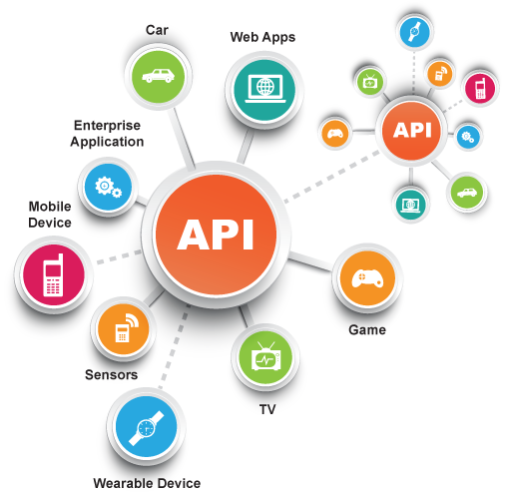

**ANGULAR JS**

AngularJS (commonly referred to as "Angular.js" or "AngularJS 1.X") is a JavaScript-based open-source front-end web application framework mainly maintained by Google and by a community of individuals and corporations to address many of the challenges encountered in developing single-page applications. The JavaScript components complement Apache Cordova, the framework used for developing cross-platform mobile apps. It aims to simplify both the development and the testing of such applications by providing a framework for client-side model–view–controller (MVC) and model–view–view-model (MVVM) architectures, along with components commonly used in rich Internet applications. In 2014, the original AngularJS team began working on Angular (Application Platform).

The AngularJS framework works by first reading the HTML page, which has embedded into it additional custom tag attributes. Angular interprets those attributes as directives to bind input or output parts of the page to a model that is represented by standard JavaScript variables. The values of those JavaScript variables can be manually set within the code, or retrieved from static or dynamic JSON resources.

According to JavaScript analytics service Libscore, AngularJS is used on the websites of Wolfram Alpha, NBC, Walgreens, Intel, Sprint, ABC News, and approximately 12,000 other sites out of 1 million tested in October 2016. AngularJS is the 10th most starred project of all time on GitHub.

AngularJS is the frontend part of the MEAN stack, consisting of MongoDB database, Express.js web application server framework, Angular.js itself, and Node.js server runtime environment.

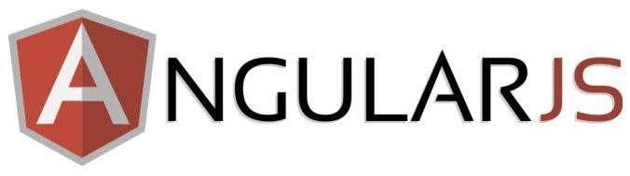

* **Features of AngularJS –**

1. AngularJS is a powerful JavaScript based development framework to create RICH Internet Application(RIA).
2. AngularJS provides developers options to write client side application (using JavaScript) in a clean MVC(Model View Controller) way.
3. Application written in AngularJS is cross-browser compliant. AngularJS automatically handles JavaScript code suitable for each browser.
4. AngularJS is open source, completely free, and used by thousands of developers around the world. It is licensed under the Apache License version 2.0.

**HARDWARE AND SOFTWARE REQUIREMENTS**

* **HARDWARE REQUIREMENTS-**

The selection of hardware is very important in the existence and proper working of any software. In the selection of hardware, the size and the capacity requirements are also important**.**

* Pentium processor - 233 MHZ or above
* RAM Capacity - 4.00 GB
* Hard Disk - 500GB
* Floppy disk - 1.44MB
* CD-ROM Drive - 32HZ
* KEYBOARD - 108 Standard
* **SOFTWARE REQUIREMENTS-**

One of the most difficult tasks is that, the selection of the software, once system requirement is known is determining whether a particular software package fits the requirements. After initial selection further security is needed to determine the desirability of particular software compared with other candidates.

* Text Editor- Sublime Text /Atom /Notepad + +
* Operating System -Windows 7/8/8.1/10
* Browser- Chrome/ Mozilla Firefox
* Internet connection
* Hard disk space for installation
* **TECHNOLOGICAL REQUIREMENTS –**
* HTML -5
* CSS 3
* Bootstrap
* JavaScript
* jQuery
* CDN Links for adding additional libraries.

**SDLC MODEL USED**

Software Development Life Cycle (SDLC) is a process used by the software industry to design, develop and test high quality softwares. The SDLC aims to produce a high-quality software that meets or exceeds customer expectations, reaches completion within times and cost estimates.

* SDLC is the acronym of Software Development Life Cycle.
* It is also called as Software Development Process.
* SDLC is a framework defining tasks performed at each step in the software development process.
* ISO/IEC 12207 is an international standard for software life-cycle processes. It aims to be the standard that defines all the tasks required for developing and maintaining software.

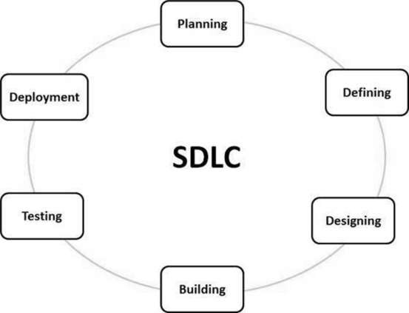

There are various software development life cycle models defined and designed which are followed during the software development process. These models are also referred as Software Development Process Models". Each process model follows a Series of steps unique to its type to ensure success in the process of software development.

Following are the most important and popular SDLC models followed in the industry:-

* Waterfall Model
* Iterative Model
* Spiral Model
* V-Model
* Big Bang Model

Other related methodologies are Agile Model, RAD Model, Rapid Application Development and Prototyping Models.

Every software developed is different and requires a suitable SDLC approach to be followed based on the internal and external factors. In this project we have used waterfall model for representing our SDLC. Some situations where the use of Waterfall model is most appropriate are −

* Requirements are very well documented, clear and fixed.
* Product definition is stable.
* Technology is understood and is not dynamic.
* There are no ambiguous requirements.
* Ample resources with required expertise are available to support the product.
* The project is short.

**THE SEQUENTIAL PHASES IN WATERFALL MODEL ARE −**

* **Requirement Gathering and analysis −** All possible requirements of the system to be developed are captured in this phase and documented in a requirement specification document.
* **System Design −** The requirement specifications from first phase are studied in this phase and the system design is prepared. This system design helps in specifying hardware and system requirements and helps in defining the overall system architecture.
* **Implementation −** With inputs from the system design, the system is first developed in small programs called units, which are integrated in the next phase. Each unit is developed and tested for its functionality, which is referred to as Unit Testing.
* **Integration and Testing −** All the units developed in the implementation phase are integrated into a system after testing of each unit. Post integration the entire system is tested for any faults and failures.
* **Deployment of system −** Once the functional and non-functional testing is done; the product is deployed in the customer environment or released into the market.
* **Maintenance −** There are some issues which come up in the client environment. To fix those issues, patches are released. Also to enhance the product some better versions are released. Maintenance is done to deliver these changes in the customer environment.

All these phases are cascaded to each other in which progress is seen as flowing steadily downwards (like a waterfall) through the phases. The next phase is started only after the defined set of goals are achieved for previous phase and it is signed off, so the name "Waterfall Model". In this model, phases do not overlap.

**SOME OF THE MAJOR ADVANTAGES OF THE WATERFALL MODEL ARE AS FOLLOWS –**

* Simple and easy to understand and use
* Easy to manage due to the rigidity of the model. Each phase has specific deliverables and a review process.
* Phases are processed and completed one at a time.
* Works well for smaller projects where requirements are very well understood.
* Clearly defined stages.
* Well understood milestones.
* Easy to arrange tasks.
* Process and results are well documented.

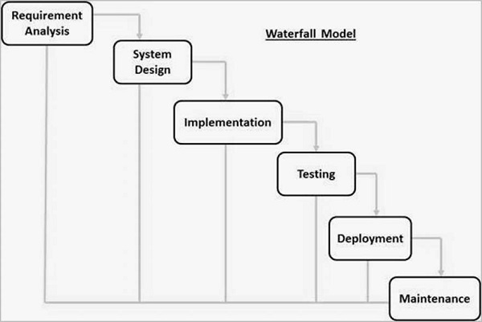

**DFD**

A data flow diagram (DFD) is a graphical representation of the "flow" of data through an information system, modeling its process aspects. A DFD is often used as a preliminary step to create an overview of the system without going into great detail, which can later be elaborated. DFDs can also be used for the visualization of data processing (structured design).

A DFD shows what kind of information will be input to and output from the system, how the data will advance through the system, and where the data will be stored. It does not show information about process timing or whether processes will operate in sequence or in parallel, unlike a traditional structured flowchart which focuses on control flow, or a UML activity workflow diagram, which presents both control and data, flows as a unified model.

**DFD 0 Diagram:**

* The level 0 data flow diagram is the diagram at the level immediately below the context diagram
* It expands the single process on the context diagram to show the major, high level processes within the project
* A context diagram is a top level (also known as Level 0) data flow diagram. It only contains one process node (process 0) that generalizes the function of the entire system in relationship to external entities. In level 0 dfd, system is shown as one process.
* The Level 0 DFD shows how the system is divided into 'sub-systems' (processes), each of which deals with one or more of the data flows to or from an external agent, and which together provide all of the functionality of the system as a whole.

**Context Flow Diagram or level 0:-**

USER

**DFD LEVEL 1:-**

SELECT YOUR MOOD FROM THE LIST OR DROPDOWN

EDM

CHEERFUL

CHILL

ACOUSTIC

ROMANTIC

PARTY

MONSOON MAGIC

MELLOW

MEDIA CONTROLLERS

**DFD LEVEL 2:-**

**ER DIAGRAM**

An entity-relationship diagram (ERD) is a graphical representation of an information system that shows the relationship between people, objects, places, concepts or events within that system. An ERD is a data modeling technique that can help define business processes and can be used as the foundation for a relational database.

* The entity relationship diagram describes the relationship between entities, cardinality and their attributes.
* The object relationship pair can be graphically represented by diagram called entity relationship diagram (ERD).
* The ERD is mainly used in database applications but now it is more commonly used in data design.
* The ERD was originally proposed by Peter Chen for design of relational database systems.
* The primary purpose of ERD is to represent the relationship between data objects.

There are five main components of an ERD:-

Entities,which are represented by rectangles. An entity is an object or concept about which you want to store information. A weak entity is an entity that must defined by a foreign key relationship with another entity as it cannot be uniquely identified by its own attributes alone.

Actions, which are represented by diamond shapes, show how two entities share information in the database. In some cases, entities can be self-linked.

Attributes, which are represented by ovals. A key attribute is the unique, entity

A multivalued attribute can have more than one value. For example, an employee entity can have multiple skill values. A derived attribute is based on another attribute. For example, an employee's monthly salary is based on the employee's annual salary.

Connecting lines, solid lines that connect attributes to show the relationships of entities in the diagram.

Cardinality specifies how many instances of an entity relate to one instance of another entity. Cordiality is also closely linked to cardinality. While cardinality specifies the occurrences of a relationship, cordiality describes the relationship as either mandatory or optional. In other words, cardinality specifies the maximum number of relationships and cordiality specifies the absolute minimum number of relationships.

SELECT GENRE/MOOD FROM TABLE

MEDIA PLAYER

USER

**SNAPSHOTS**

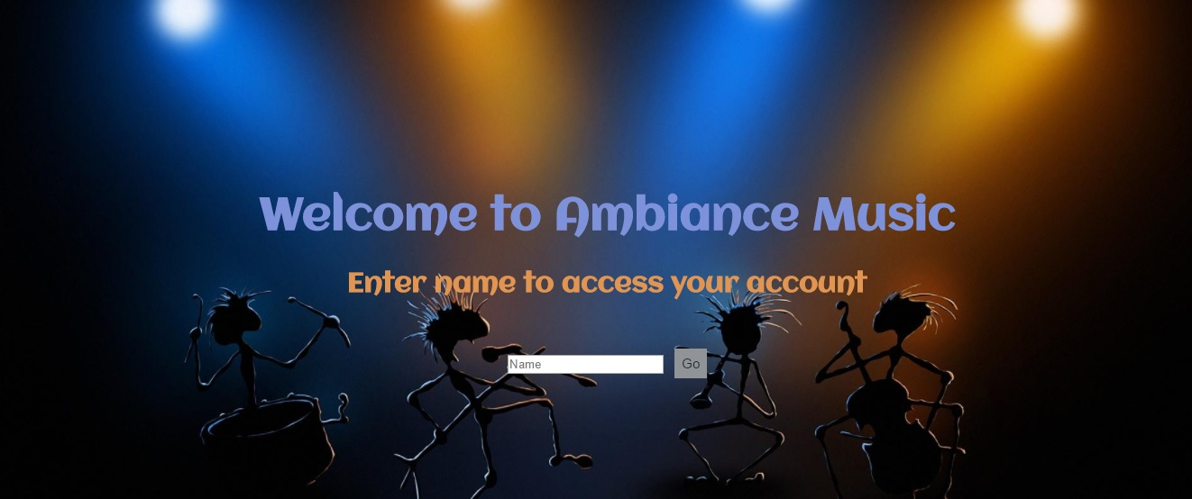

**SNAPSHOT 1**

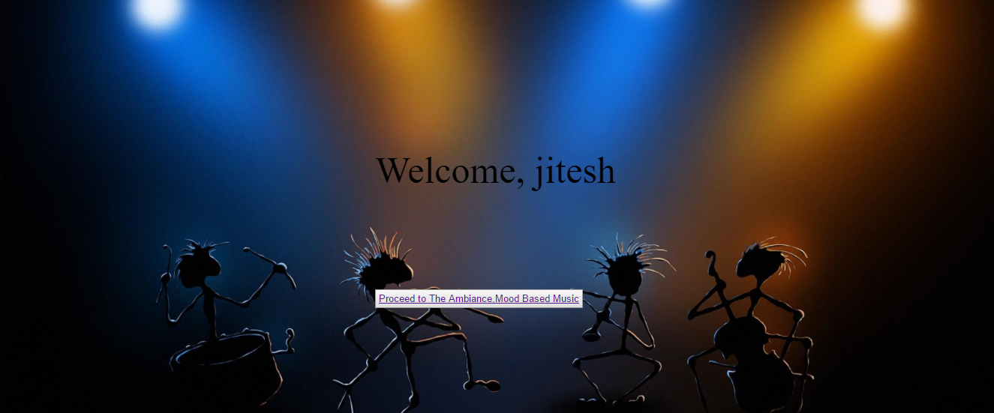

**SNAPSHOT 2**

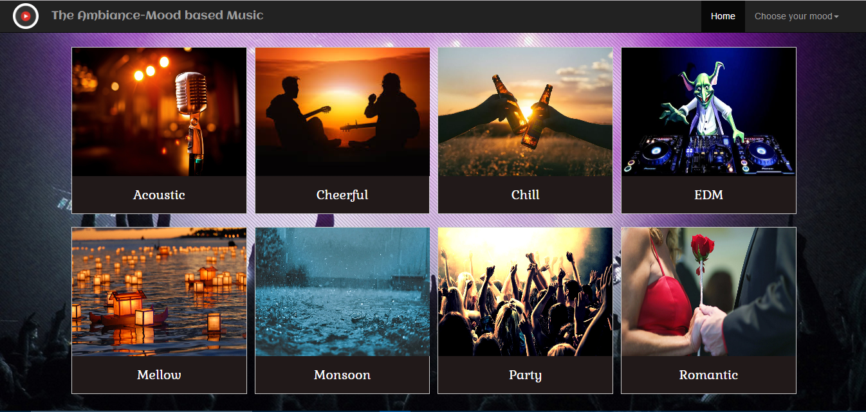

**SNAPSHOT 3**

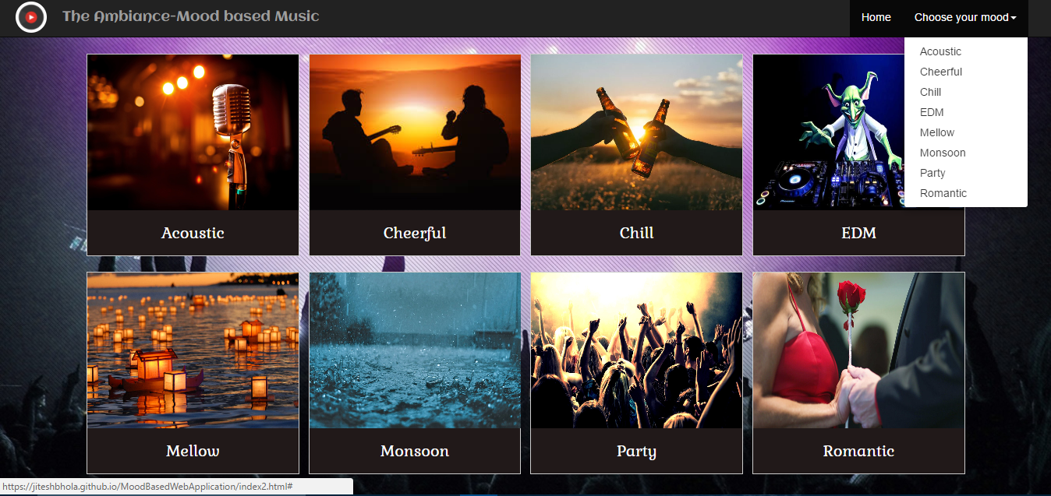

**SNAPSHOT 4**

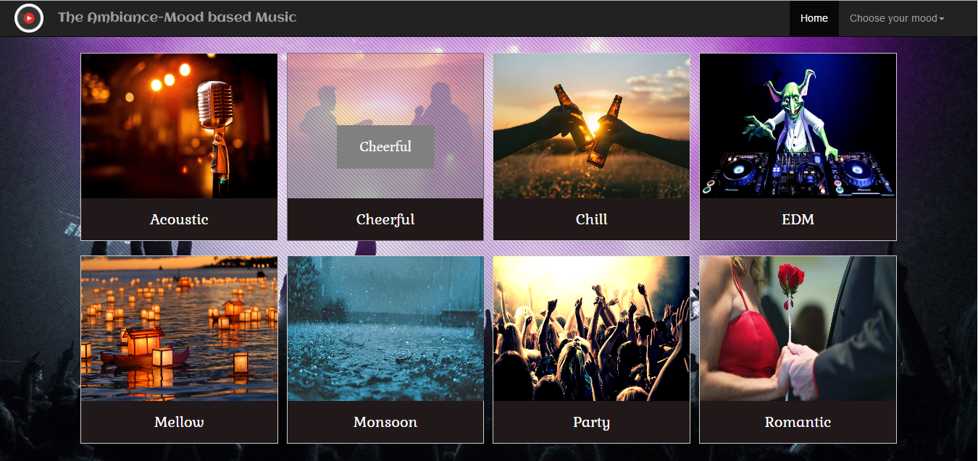

**SNAPSHOT 5**

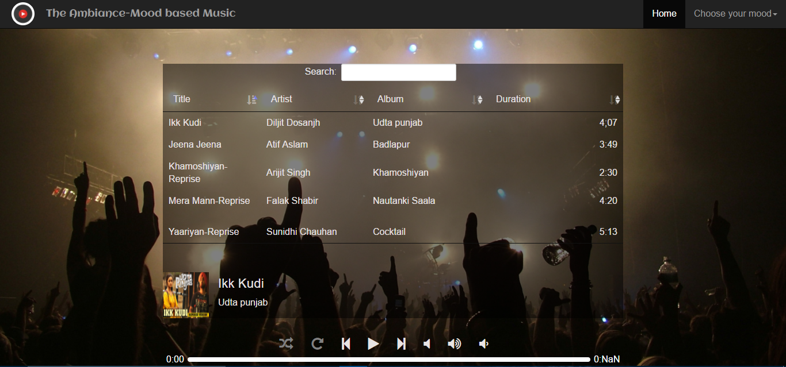

**SNAPSHOT 6**

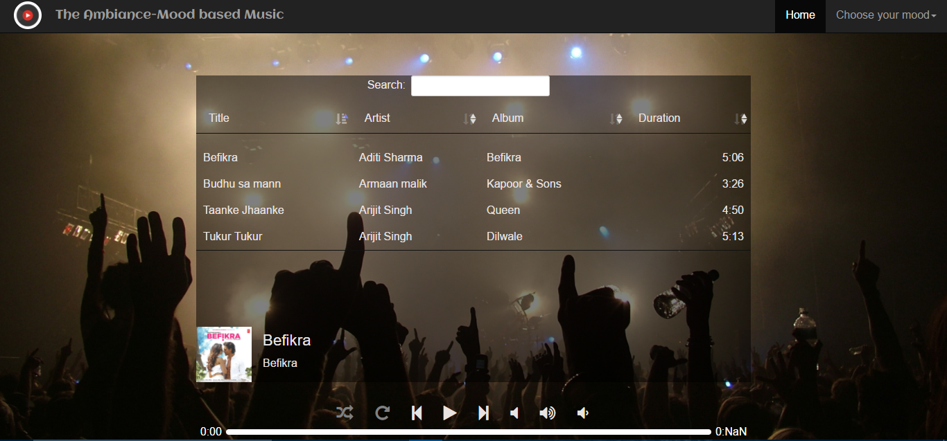

**SNAPSHOT 7**

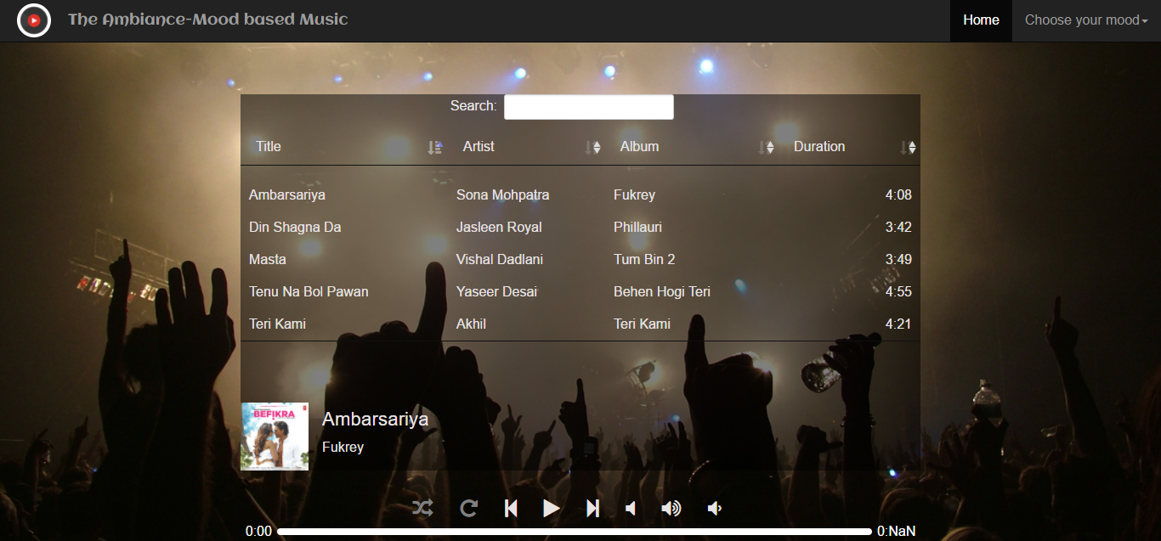

**SNAPSHOT 8**

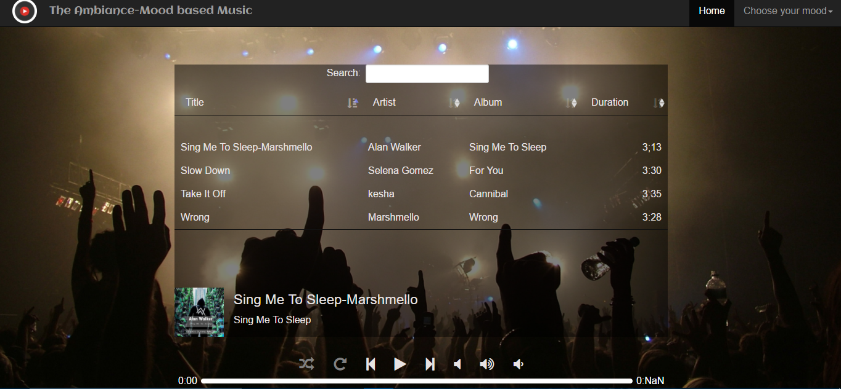

**SNAPSHOT 9**

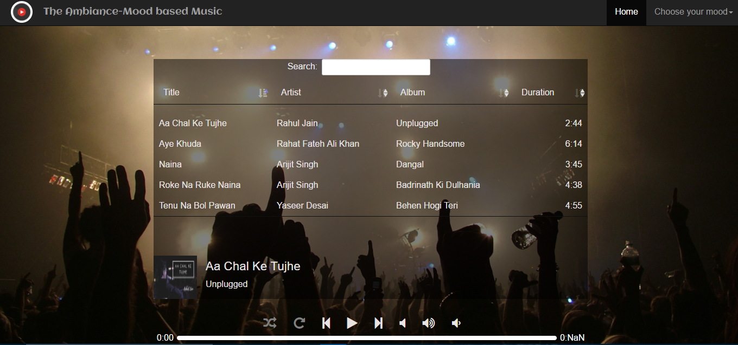

**SNAPSHOT 10**

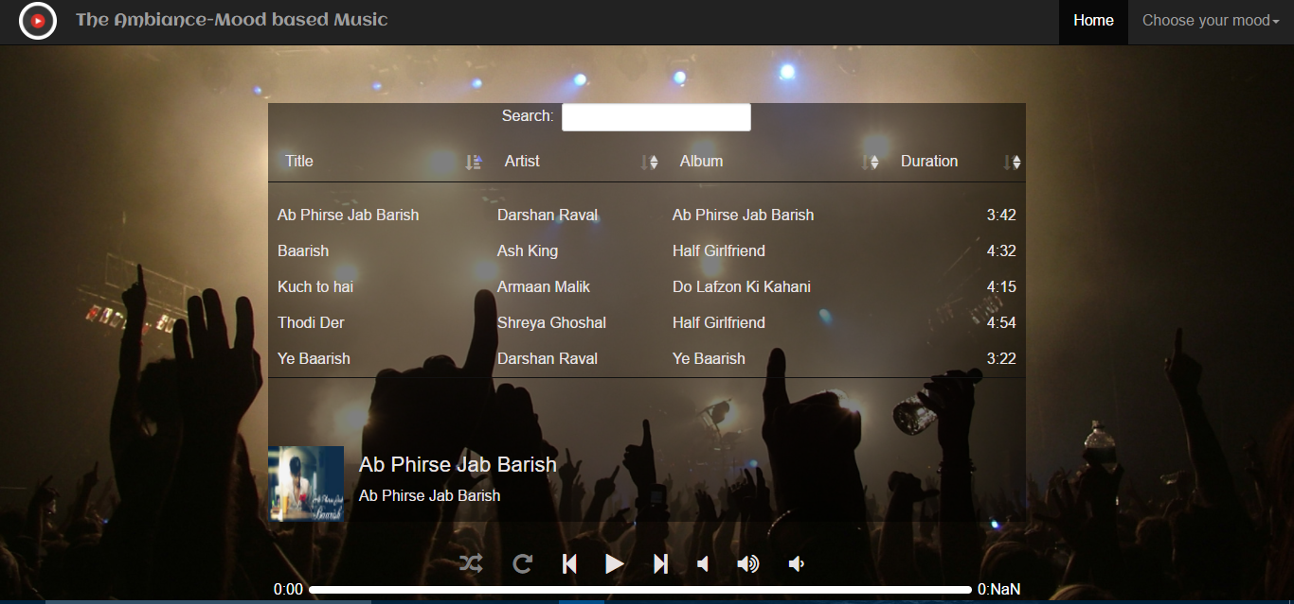

**SNAPSHOT 11**

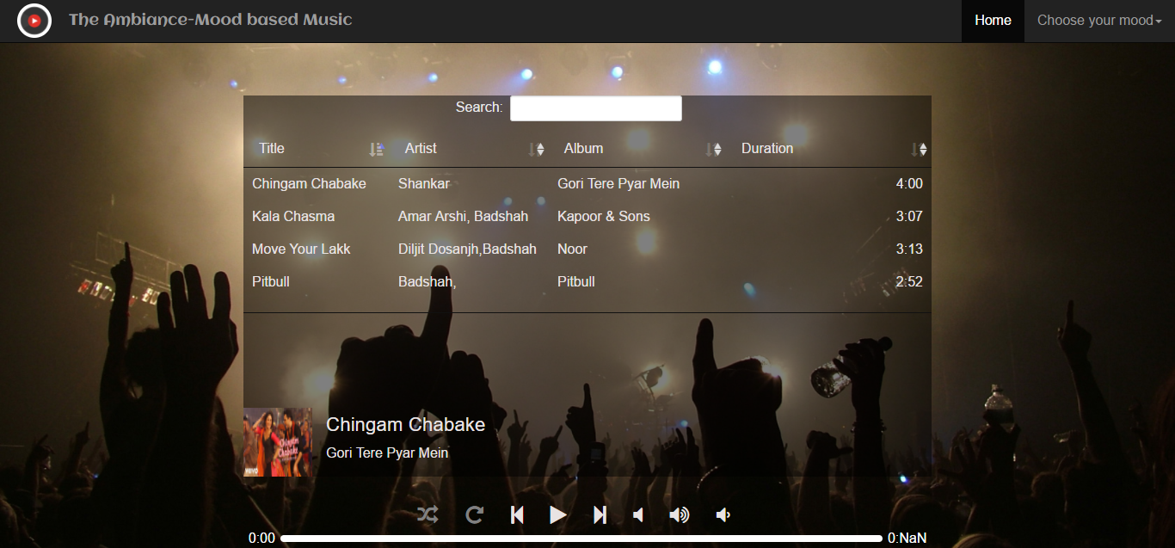

**SNAPSHOT 12**

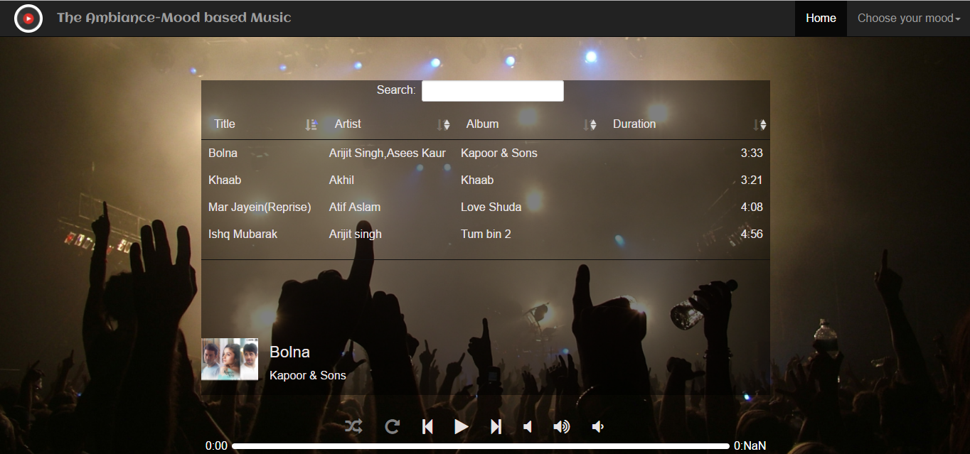

**SNAPSHOT 13**

**ADVANTAGES OF PROJECT**

1. Simple and elegant user-interface.
2. Reduces the time taken to search for particular mood based sings.
3. Auto generation of playlist based on mood.
4. Less time required to find data, greater the efficiency.
5. Mood selection can be done both from the tiles and dropdown available.
6. Fully functional media player.
7. Play and pause functionality available by click of icon and on key press of spacebar.
8. Search and sort available on each page.
9. Sorting can be done in four different ways.
10. Great advantage for people looking for people looking for a mood based music app.
11. Works perfectly on all screen sizes.

**FUTURE SCOPE**

1. Can be developed as a mobile app on android and iOs.
2. Database connectivity can be provided.
3. More songs can be added.
4. Voice control can be added to speak your name and for media controllers.
5. Facial recognition feature can be done for mood recognition.
6. Time taken can be reduced.

**REFERENCES**

1. https://en.wikipedia.org/wiki/Cascading_Style_Sheets#CSS_frameworks
2. https://developer.mozilla.org/en/docs/Web/CSS/CSS3
3. http://www.sitesbay.com/javascript/javascript-features
4. https://angularjs.org/
5. https://developer.mozilla.org/en-US/docs/AJAX/Getting_Started
6. https://en.wikipedia.org/wiki/AngularJS
7. https://www.tutorialspoint.com/angularjs/angularjs_overview.htm
8. http://www.json.org/
9. http://www.webopedia.com/TERM/C/CDN.html
10. https://cdn.datatables.net/
11. https://www.tutorialspoint.com/sdlc/sdlc_quick_guide.htm